Rajbeer Chandra

2105987

Q1.

#include<iostream>

using namespace std;

int main()

{

   std::cout<< "Hello World";

    return 0;

}

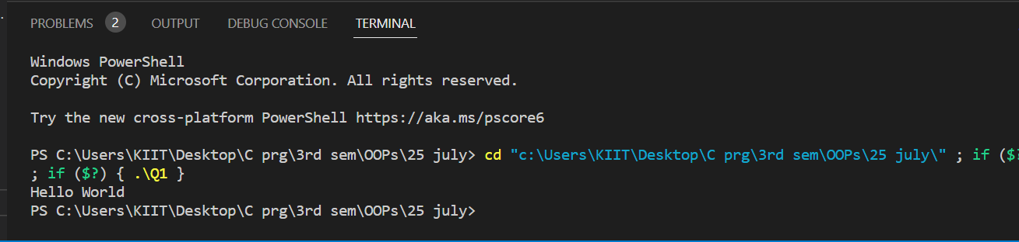

Q2.

#include<iostream>

using namespace std;

int check_prime(int);

int main()

{

    int  n1,n2,i;

    bool f;

    cout<<"Enter 2 no.";

    cin>>n1>>n2;

    cout<<"prime no.between n1 and n2\n";

    for(i=n1;i<n2;i=++i)

    {

        f=check_prime(i);

        if(f)

        cout<<i<<",";

    }

    return 0;

}

int check_prime(int n)

{

    bool is_prime =true;

    if(n==0||n==1)

    {

        is_prime=false;

    }

        for(int j = 2; j <= n/2; ++j) {

    if (n%j == 0) {

      is_prime = false;

      break;

    }

        }

    return is_prime;

}

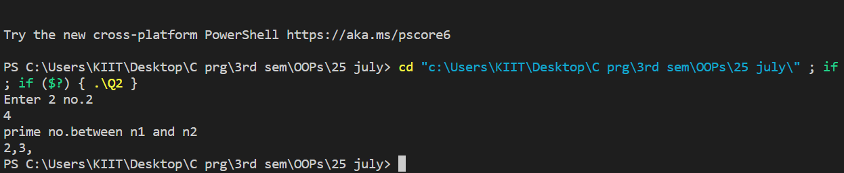

Q3.

#include <iostream>

using namespace std;

int main()

{

  int n1, n2, sum;

  cout << "Enter two integers: ";

  cin >> n1 >> n2;

  sum = n1 + n2;

  cout << n1 << " + " <<  n2 << " = " << sum;

  return 0;

}

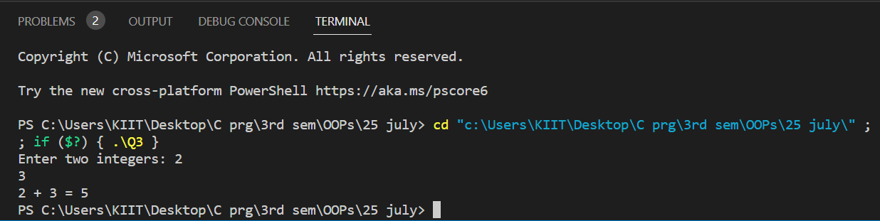

Q4.

#include <iostream>

using namespace std;

class student

{

    private:

        char  name[30];

        int   rollNo;

        int   total;

    public:

        void getDetails(void);

        void putDetails(void);

};

void student::getDetails(void)

{

    cout << "Enter name: " ;

    cin >> name;

    cout << "Enter roll number: ";

    cin >> rollNo;

    cout << "Enter total marks outof 500: ";

    cin >> total;

}

void student::putDetails(void)

{

    cout << "Student details:\n";

    cout << "Name:"<< name ;

    cout << ",Roll Number:" << rollNo;

    cout << ",Total:" << total ;

}

int main()

{

    student std;

    std.getDetails();

    std.putDetails();

    return 0;

}

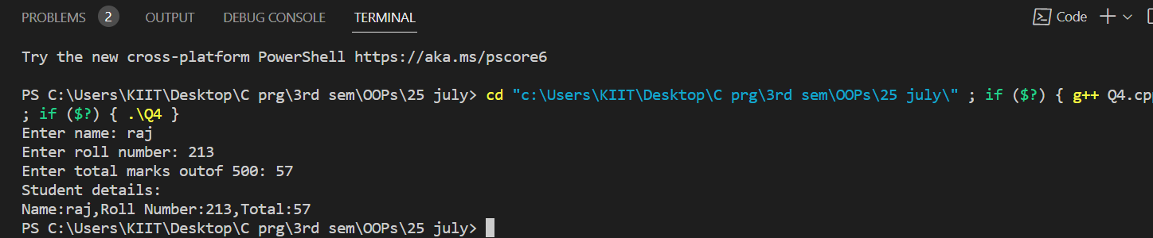

Q5.

#include<iostream>

using namespace std;

class studen

{

string name;

int roll;

int marks[10];

int tmarks=0;

float percentage;

public:

void getdata()

{

cout<<"Enter Name: ";

cin>>name;

cout<<"Enter Roll Number: ";

cin>>roll;

cout<<"Enter Marks of five subjects: ";

for(int i=0; i<10; i++)

{

cout<<"Enter Marks of Subject "<<i+1<<" : ";

cin>>marks[i];

tmarks = (tmarks + marks[i]);

}

}

void display()

{

cout<<"Student's Name: "<<name<<endl;

cout<<"Roll Number: "<<roll<<endl;

for(int i=0; i<10; i++)

{

cout<<"Marks of Subject "<<i<<" : ";

cout<<marks[i]<<endl;

}

cout<<"Total Marks: "<<(tmarks)<<endl;

cout<<"Percentage : "<<(tmarks/10)<<"%"<<endl;

}

};

int main()

{

 string s;

s.getsdata();

s.display();

return 0;

}

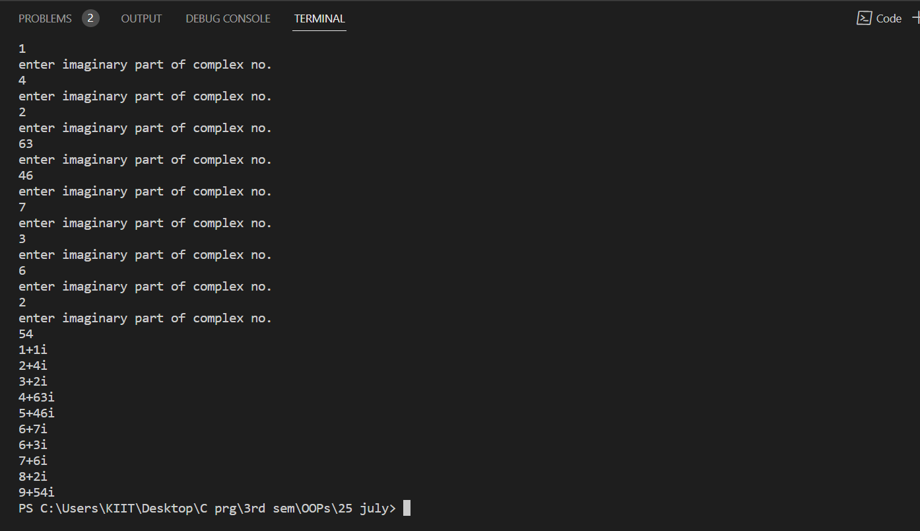

Q6.

#include<iostream>

using namespace std;

class Complex{

public:

    int real;

    int imag;

     void setvalue1()

    {

        cout<<"enter real part of complex no."<<endl;

        cin>>real;

    }

    void setvalue2()

    {

        cout<<"enter imaginary part of complex no."<<endl;

        cin>>imag;

    }

    void display()

    {

        cout<<real<<"+"<<imag<<"i"<<endl;

    }

    };

int main()

    {

        Complex c[10];

        for(int i=0;i<10;i++)

        {

            c[i].setvalue1();

        }

        for(int i=0;i<10;i++)

        {

            c[i].setvalue2();

        }

        for(int i=0;i<10;i++)

        {

            c[i].display();

        }

    return 0;

    }

Q7.

#include <iostream>

#include <bits/stdc++.h>

using namespace std;

class distanceformula{

    public:

    int x1, y1,  x2, y2;

   float result;

    void input(){

        cout << "enter x1:  \n";

        cin >> x1;

        cout << "enter y1:  \n";

        cin >> y1;

        cout << "enter x2:  \n";

        cin >> x2;

        cout << "enter y2:  \n";

        cin >> y2;

    }

    void calculate() {

        result = sqrt(pow(x2 - x1, 2) + pow(y2 - y1, 2) * 1.0);

        cout << result;

    }

};

int main (){

    distanceformula d1;

    d1.input();

    d1.calculate();

}

